#### الطاقة النيابية" تزور جامعة الحسين التقنية - Alghad

**National ICT Up-skilling Program**

**(Web Development)**



**Ministry of Higher-Education Website**

**-** **Instructors**

-Mr. Jalal AL-Kiswani.

-Mrs.Jaquelyn Brown.

-Mr. William Smairat.

**-Prepared by**

-Bara` a Badarneh.

**October 20, 2020**

**TABLE OF CONTENTS**

**1-Introduction ----------------------------------------------------------------------------------------- 3**

**2-Technology ------------------------------------------------------------------------------------------- 4**

**2.1 Front-End-----------------------------------------------------------------------------------------------------**

2.1.1 HTML **------------------------------------------------------------------------------------------------------- 5**

2.1.2 CSS**-----------------------------------------------------------------------------------------------------------**

2.1.3 JavaScript**--------------------------------------------------------------------------------------------------**

**2.2 Back-End------------------------------------------------------------------------------------------------------**

2.2.1 PHP-----------------------------------------------------------------------------------------------------------

**2.3 Database------------------------------------------------------------------------------------------------------- 6**

2.3.1 MySQL-------------------------------------------------------------------------------------------------------

**2.4-Modeling** ------------------------------------------------------------------------------------------------------ **7**

2.4.1X-Mind -------------------------------------------------------------------------------------------------------

2.4.2 Draw.io --------------------------------------------------------------------------------------------------**---- 8**

2.4.3 Proto.io ------------------------------------------------------------------------------------------------------

2.4.4Visual Studio Code----------------------------------------------------------------------------------

**2.5Version control** --------------------------------------------------------------------------------------- **9**

2.5.1GitHub --------------------------------------------------------------------------------------------------------

**3-Requierments** --------------------------------------------------------------------------------------------------- **10**

3.1 Users -------------------------------------------------------------------------------------------------------------

3.2 Functional Requirements -------------------------------------------------------------------------------------

3.3 Pages Description ----------------------------------------------------------------------------------------------

**4-Design** -------------------------------------------------------------------------------------------------------------

4.1 wireframe ------------------------------------------------------------------------------------------------------- **12**

4.2 mockup ----------------------------------------------------------------------------------------------------------

4.3 prototype -------------------------------------------------------------------------------------------------------- **16**

4.4 ERD ------------------------------------------------------------------------------------------------------------- **17**

**5-Development** ---------------------------------------------------------------------------------------------------- **18**

5.1-Front-end developer ------------------------------------------------------------------------------------------ **19**

5.2- Backend developer -------------------------------------------------------------------------------------------

**6-Testing ------------------------------------------------------------------------------------------------------------ 21**

**7-Deployment------------------------------------------------------------------------------------------------------ 22**

7.1 Domain----------------------------------------------------------------------------------------------------------

7.2 Hosting-----------------------------------------------------------------------------------------------------------

**8-Screenshots**------------------------------------------------------------------------------------------------------ **23**

**9-Concusion-------------------------------------------------------------------------------------------------------- 29**

**10-Referrnces ------------------------------------------------------------------------------------------------------ 30**

**Ministry of Higher-Education Website**

1. **Introduction**

Hussein Technical University's training for IT graduates, in cooperation with the Ministry of Digital Economy, ends with a project to measure the efficiency of the training and assess the capabilities and skills of the student that he learned during this training. We, the team of full stack web developers, had our mission to develop a website for a ministry of Jordanian ministries and for the site to contain electronic services. This report talks about the project, its idea and the sequence of steps of its work.

I choose the Ministry of Higher-Education website to be the ministry that I work my final internship project, It is one of the most important ministries and provides a large and important group of services to a large and active group in society, so my project goal That the site of this ministry be an easy-to-use and error-free site that contains all services easily and flexibly for its users, saves them time and effort, and has a high level of creativity and flexibility. With the presence of electronic services to facilitate the exchange of services between the ministry and students in faster and easier way, also to reduce cost and effort.

To complete my project, I set a plan to complete the work steps in an organized and arranged manner, which helped me accomplish the site and achieve my goals, in addition to that, I used modern programming languages ​​and a set of software and work environments that keep pace with modern programming technology.

**2-Technologies:**

The development and design of my website I used many modern, advanced and related technologies to create the site in an integrated, coherent and effective way, in this part I will talk about this technology:

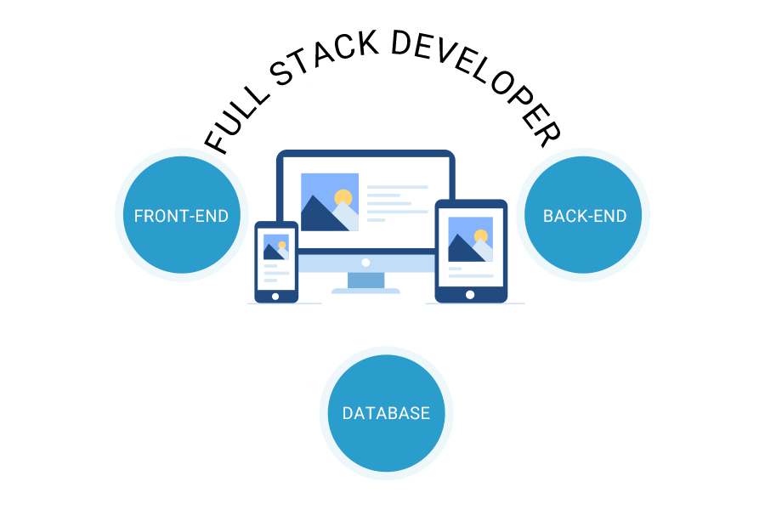

Figure (1): Full-stack Web Development Technologies.

**2.1-Front-End:** The website’s front end is everything you see and can interact with using a browser. So, creating this visual part is called front-end development. You could even say that designers creating user interfaces and planning experiences are also front-end developers, as they are working in collaboration on the same part of the project. I used HTML, CSS, and JavaScript in my own project.



Figure (2): Front-end Web Development Technologies.

**2.1.1-HTML (Hypertext Markup Language):** is the most basic building block of the Web. It defines the meaning and structure of web content. Other technologies besides HTML are generally used to describe a web page's appearance/presentation (CSS) or functionality/behavior (JavaScript).

**2.1.2-CSS (Cascading Style Sheets):** is a markup language responsible for how your web pages will look like. It controls the colors, fonts, and layouts of your website elements.

**2.1.3- JavaScript:** is a programming language commonly used in web development. It was originally developed by Netscape as a means to add dynamic and interactive elements to websites.

**2.2-Back-End:** the part of a web application that is unrevealed to the user. Unlike front-end, back-end development operations are not very easy and usually turn out to be complicated and manifold; this part is in alignment with the server. Backend operations are a lot different that are controlled by different programming languages.

**2.2.1-PHP (Personal Home Page):** is a server-side scripting language designed for web development but also used as a general-purpose programming language. PHP codes are simply mixed with HTML codes and can be used in combination with various web frameworks. Its scripts are executed on the server. PHP code is processed by a PHP interpreter. The main goal of PHP is to allow web developer to create dynamically generated pages quickly.

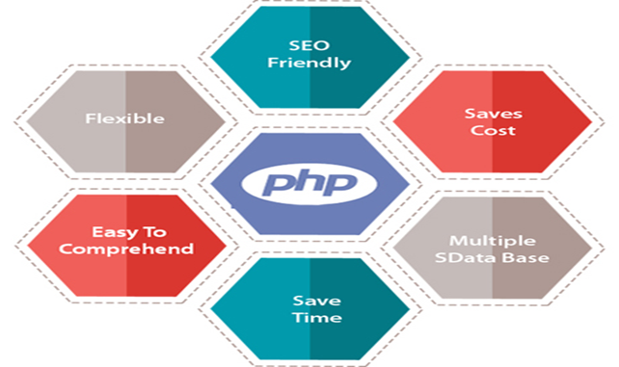

Figure (3): Php Features.

**2.3- Database:**

A database is a collection of information that is organized so that it can be easily accessed, managed and updated. Computer databases typically contain aggregations of data records or files, containing information about sales transactions or interactions with specific customers.

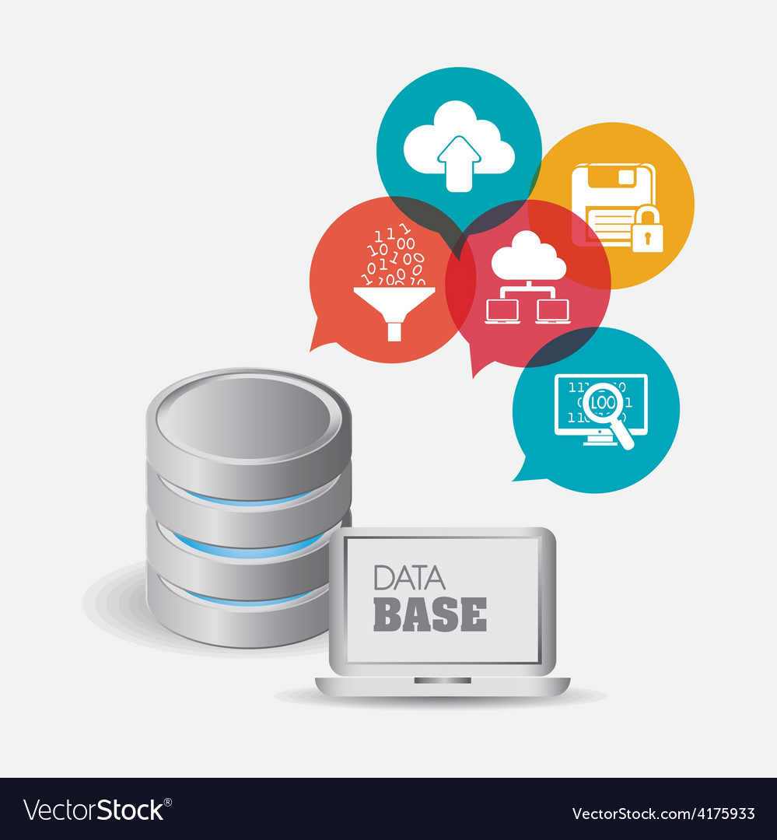

Figure (4): Database Technologies.

**2.3.1- MySQL:** is an open source relational database management system. It is based on the structure query language ([SQL](https://techterms.com/definition/sql)), which is used for adding, removing, and modifying information in the database. Standard SQL commands, such as add, drop, insert, and update can be used with MySQL.

Many database-driven websites that use MySQL also use a Web scripting language like [PHP](https://techterms.com/definition/php) to access information from the database. MySQL commands can be incorporated into the PHP code, allowing part or all of a Web page to be generated from database information. Because both MySQL and PHP are both open source (meaning they are free to download and use), the PHP/MySQL combination has become a popular choice for database-driven websites.



Figure (5): MySQL Technologies.

**2.4-Modeling:**

It is a process of designing the site, but without writing code, in order to present it to the customer and take his opinion and notes and amend them before starting the programming process, and this saves time, money and effort, and organizes all the steps:

**2.4.1-X-Mind:** a full-featured mind mapping and brainstorming tool, designed to generate ideas, inspire creativity, brings efficiency both in work and life. I used it in my project to build a site-map for the general content of my site.

Figure (6): 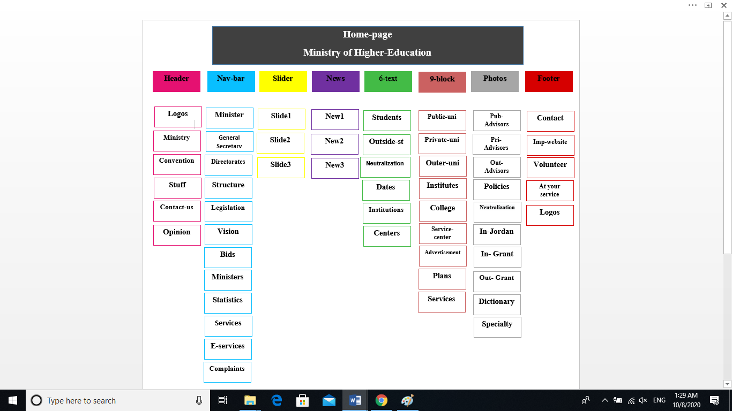 Figure (6): Site-Map.

**2.4.2- Draw.io:**  is a free online diagramming software application for building diagramming applications. It also produces web-based diagramming technology, which I use to design the wireframe and the ERD in the project.

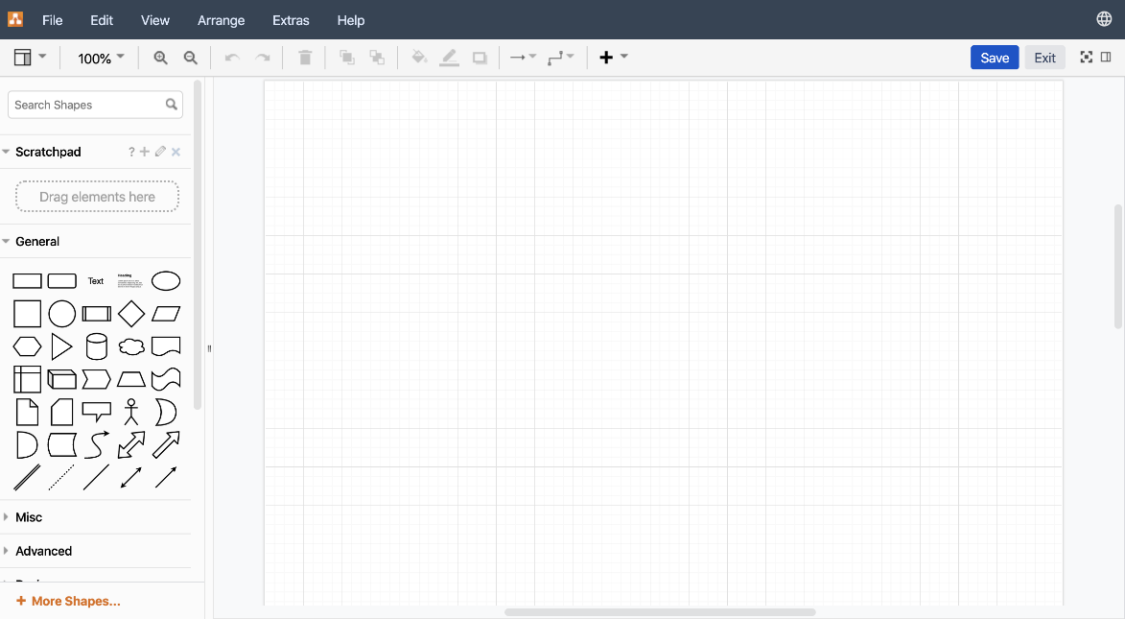

Figure (7): Draw.io Technologies.

**2.4.3- Proto.io:**  is the new state transitions feature makes it easy for anyone with no design or coding skills to create beautiful animations in no time. You can now preview animations right in the editor as you craft your motion design. I use it to create the mockups.

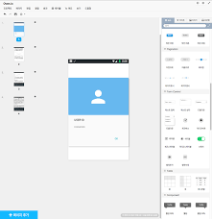

Figure (8): Proto.io Technologies.

**2.4.4- Visual Studio Code:** is a lightweight but powerful source **code** editor which runs on your desktop and is available for Windows, mac OS and Linux. It comes with built-in support for JavaScript, Typescript and Node.it used in the project for coding (HTML.CSS, PHP, and JavaScript) in the prototype part.



Figure (9): Visual Studio Code Environment.

**2.5-Version control:**

**2.5.1GitHub**: is a website and service that we hear geeks rave about all the time, yet a lot of people don’t really understand what it does, Git is a command-line tool, but the center around which all things involving Git revolve is the hub—GitHub.com—where developers store their projects and network with like-minded people, we used it to upload our project and assignments to the instructor during the training. So it is the Interact session with the technical instructor.

* Git is the preferred version control system of most developers, since it has multiple advantages over the other systems available. It stores file changes more efficiently and ensures file integrity better.

**3-Requierments:**

### Personal requirements for a Web Developer

* Creative
* Aptitude for technical tasks
* Good communication skills
* Able to work as part of a team
* Committed to understanding new technology and upgrading skills

**3.1-Users:**

The purpose is to make the website easier, more elegant, saving time, effort and money, and completing tasks and requirements quickly and without any problems, with some electronic services. All the goals are achieved.

**3.2-Functional Requirements:**

The user can do almost of the services online, so he can certify and recognize certificates, knowing the places of attestation, the recognized foreign universities, in addition to the local universities and colleges, and many services, such as participating in training or volunteering with the Ministry, in order to invest and develop energies and capabilities.

**3.3:-Pages Description:**

I designed more than 25 pages in my website, the home-page present all the other pages and services, I used the same header and footer for all the pages, but I choose different body which fits with the purpose of the page, the services it provides, and the information it contains.

There is a webpage for the employee to login in there e-gates that helps them to do their works easily, also there are pages that talks about the ministry, the current minster and the previous minsters, the mission and values ​​of the Ministry, in addition to the bids and statistics related to it, enables the user to submit complaints and suggestions in different and easy ways to be dealt with quickly and flexibly. The website contains information and the websites for the local public, private, collages, and institutes, also the recognized universities outside Jordan.

In addition to electronic services, certifying certificates, equivalence and requesting recognition, as well as providing other services such as volunteering and training with the Ministry to make young people an effective part of society, investing their energies in a useful way, and developing their skills and their scientific and personal capabilities, which makes them ready for the labor market.

Also I designed webpages for the important sites like: The official website of His Majesty King Abdullah II and Prince Al Hussein, the site of Queen Rania and the Amman Message, in addition to the sites of other Jordanian ministries and your platform service site.

I chose the green, black, red and white colors in my design of the site based on the colors of the flag of Jordan, since it is a site for an official ministry in addition to that the colors white and black are trends of web design for 2020. So that will make my website trendy and elegant.

**4-Design:**

Encompasses many different skills and disciplines in the production and maintenance of [websites](https://en.wikipedia.org/wiki/Website). The different areas of web design include web graphic design. It is the process that built the website from zero until it uploaded into the internet. The next steps are the process of design a webpage and some examples for each process from my website:

**4.1-Wireframes:** are an important design tool used in Web development. It is a visualization tool for presenting proposed functions, structure and content of a Web page or Web site. A wireframe separates the graphic elements of a Web site from the functional elements in such a way that Web teams can easily explain how users will interact with the Web site. A typical wireframe includes:

1-Key page elements and their location, such as header, footer, navigation, content objects, and branding elements.

2- Grouping of elements, such as side bars, navigation bars, and content areas.

3- Labeling, page title, navigation links, headings to content objects.

4- Place holders, content text and images.

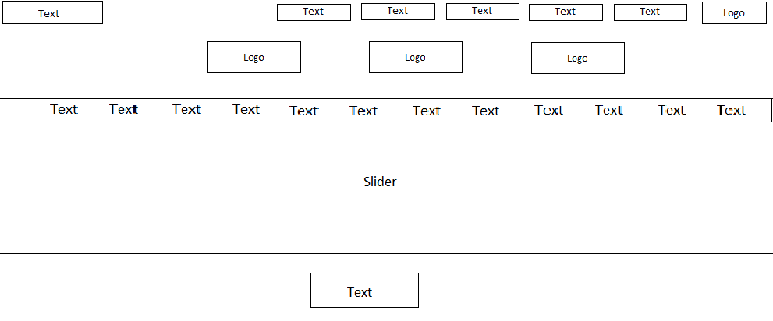

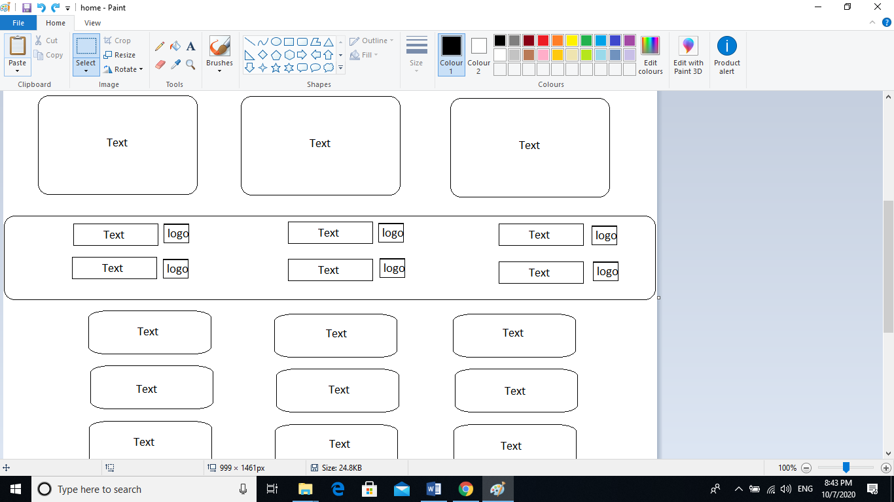

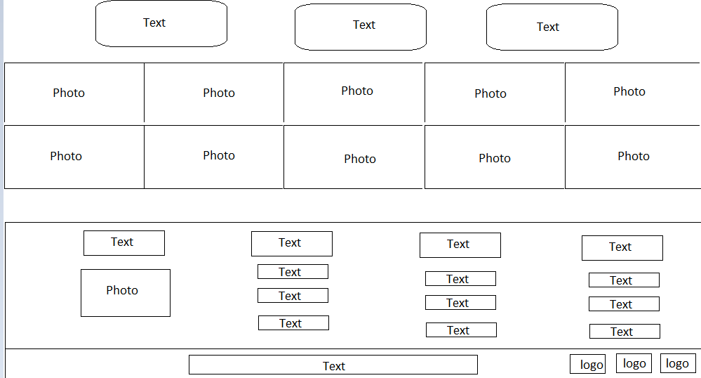

Figure (10): Wireframe Home-page.

**4.2-Mockup:** is a high-fidelity simulation of how a website will look. Website mockups combine the structure and logic of a wireframe but with the images, graphics and UI elements that the final product will have. It does not include the transitions and usable functions you’ll see in a prototype and in the final product, mockups help us define:

1. Information architecture: how you organize your website’s information logically and hierarchically
2. User flow: how the user will interact with your website and the navigation UX
3. Visual hierarchy and layout: how all the elements appear on your webpages, their size and position relative to one another and the spacing between
4. Color: nearly always contain the color scheme you’ll use in the final product
5. -Typography: contain the exact fonts types, sizes and boldness that your final product will have
6. Images: Use SVGs and high quality images that mirror exactly the ones you’ll include in your final product
7. Interaction.

**Why design a website mockup?**

There are many reasons why it’s a good idea to design a website mockup. The short answer is that it gets your product to the market more efficiently, reduces development costs and increases the chances of its long term success. Here’s how:

1. Catch design errors early.
2. Implement valuable feedback early.
3. Improve collaboration and communication with your development team.

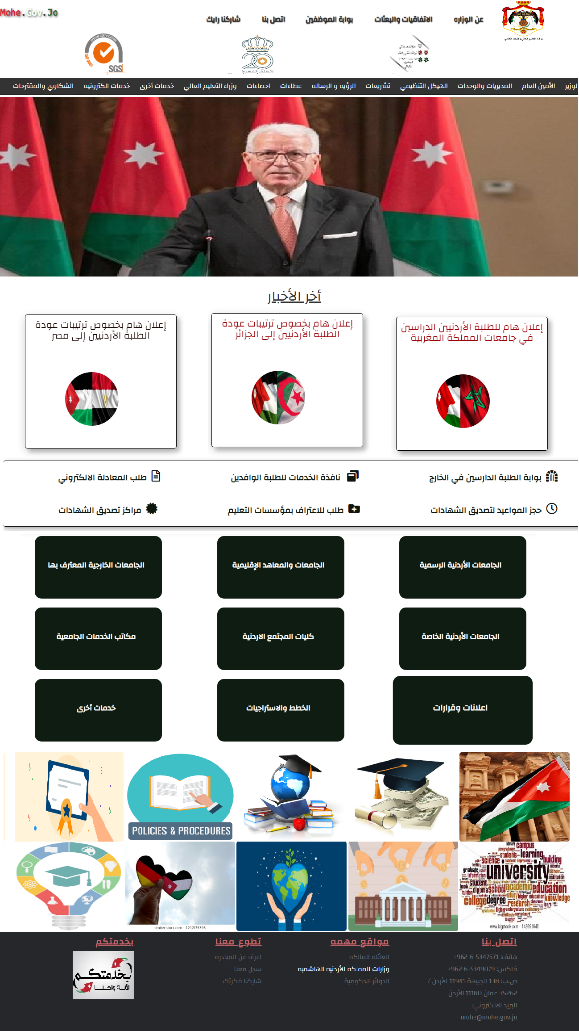

Figure (11) Mockup Home-page.

**4.3-Prototype:** takes it to a whole new level by adding interactions and animation and giving a user a look and feel of what an end product will look like. I used a very modern programing languages (HTML, CSS, JavaScript, Bootstrap and Php).

**\*The color of my website changes between (Red, Green, and Black) every 30 second.**

*Prototyping Use Cases:

1. Visualize your idea to get a better understanding of the details;
2. Share your website design concept with the business partners, peers, and friends;
3. Provide a clear reference of what you are looking for when hiring designers and software development team;
4. Perform user testing and get actionable feedback.

-The prototype in my project is same as the mockup, but with motions.

**4.4-ERD (Entity Relation Diagram):** An entity relationship diagram (ERD) shows the relationships of entity sets stored in a database. An entity in this context is an object, a component of data. An entity set is a collection of similar entities. These entities can have attributes that define its properties.

By defining the entities, their attributes, and showing the relationships between them, an ER diagram illustrates the logical structure of databases. ER diagrams are used to sketch out the design of a database.

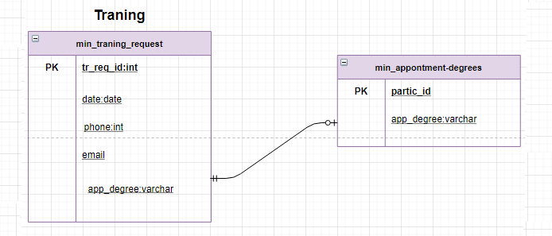

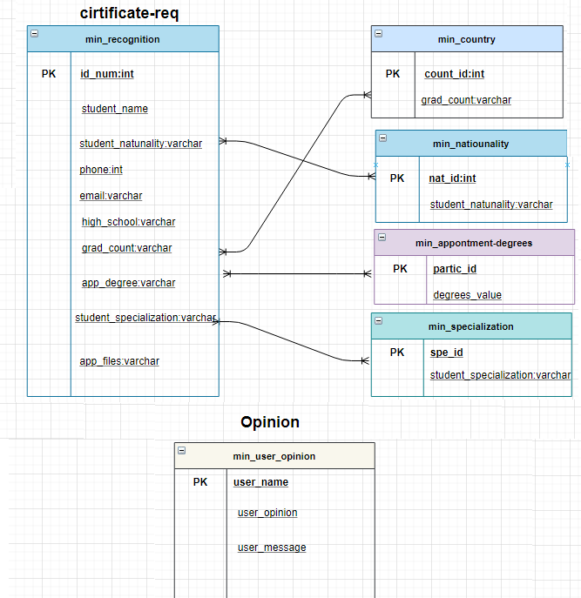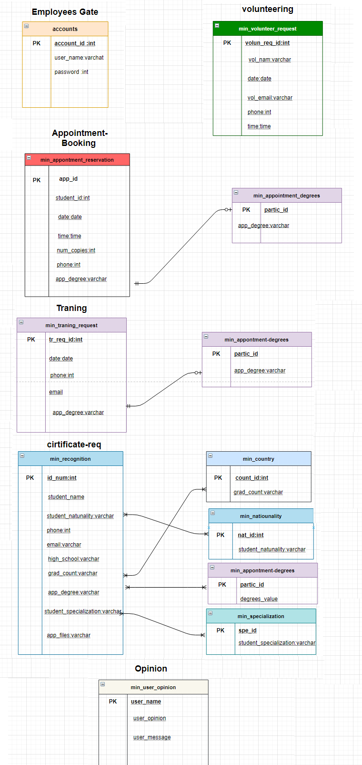

Figure (12): ERD Diagram.

**5-Development:**

**5.1-Front-end takes care of layout:** design and interactivity using HTML, CSS and JavaScript. They take an idea from the drawing board and turn it into reality

What you see and what you use, such as the visual aspect of the website, the drop down menus and the text, are all brought together by the front-end, who writes a series of programs to bind and structure the elements, make them look good and add interactivity. These programs are run through a browser.

*in my project (HTML, CSS, JavaScript).

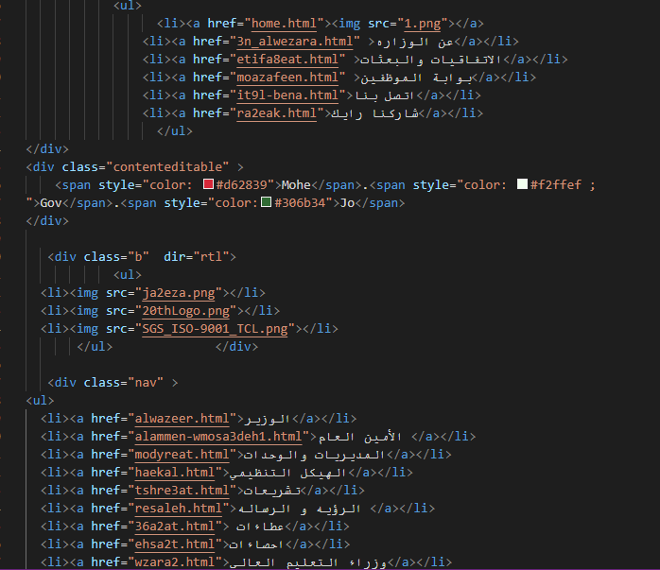Figure (13): HTML Header source code.

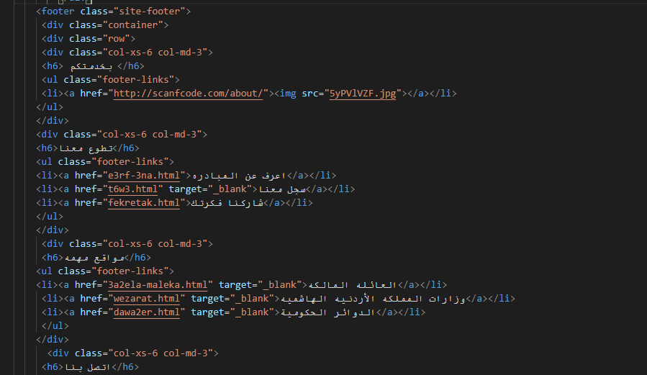

Figure (14): HTML Footer source code.

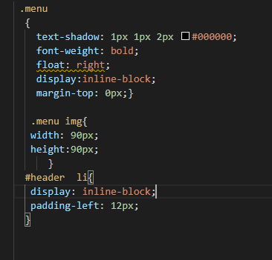

Figure (15): Sample of CSS source code.

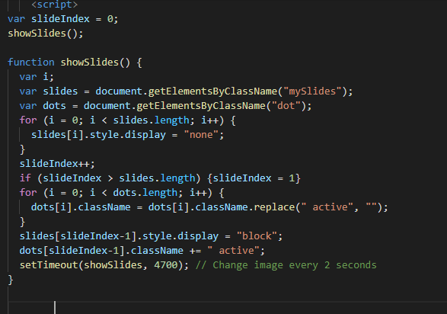

Figure (16): Sample of JavaScript source code.

**5.2- Backend developer:** what is going on behind the scenes, this is where the data is stored, and without this data, there would be no frontend. The backend of the web consists of the server that hosts the website, an application for running it and a database to contain the data. The backend uses computer programs to ensure that the server, the application and the database run smoothly together.

*in my project (Php, MySQL).

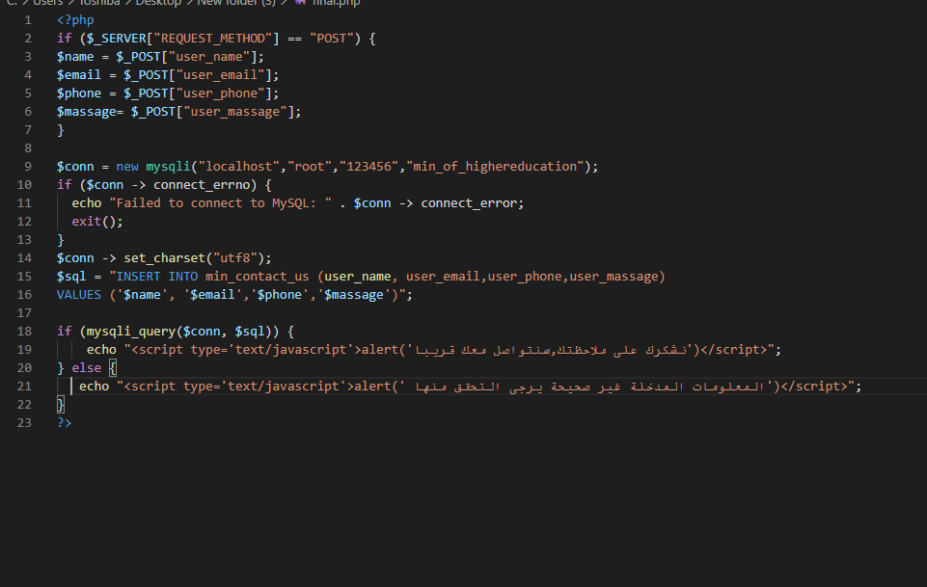

Figure (17): Sample of Php source code.

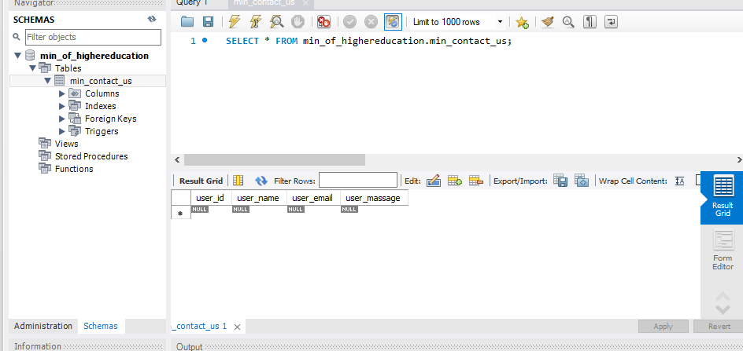

Figure (18): Sample of MySQL Table.

**6-Testing:**

|  |  |  |  |  |  |
| --- | --- | --- | --- | --- | --- |
| **Test**  **ID** | **Test case &User actions** | **Test Data** | **Expected Result** | **Actual Result** | **Comment** |
| **1** | User_name&password  Click on “sign-in “button. | Username&  password | Display massage  “ Confirm the information” | Valid massage displayed | Working properly |
| **2** | Make complaint Click on “send “button. | Username  Phone  massage | Display massage  “ Confirm the information” | Valid massage displayed | Working properly |
| **3** | Your opinion Click on “send “button. | Opinion  massage | Display massage  “ Confirm the information” | Valid massage displayed | Working properly |
| **4** | Training Click on “send “button. | Username  Phone  massage | Display massage  “ Confirm the information” | Valid massage displayed | Working properly |
| **5** | Your ideas Click on “send “button. | Username  Phone  idea | Display massage  “ Confirm the information” | Valid massage displayed | Working properly |
| **6** | Volunteering Click on “send “button. | Username  Phone | Display massage  “ Confirm the information” | Valid massage displayed | Working properly |

A web-based system needs to be checked completely from end-to-end before it goes live for end users.

**7-Deployment:**

Means to push changes or updates from one deployment environment to another. When setting up a website you will always have your live website, which is called the live environment or pro.While deployment models can vary, the most common is the classic “left to right” deployment model when working with multiple deployment environments. In this model changes are made in local, development or staging environments (depending on the setup) and pushed from left to right through the different environments ending up in the live environment. Once this deployment process has completed the new changes will be visible in the live environment.



Figure (19): Deployment process .

**7.1-Domain:** is an actual presence on the Internet, such as a web page. Specifically speaking, a web domain name is a substitute that replaces the Internet Protocol (IP) address. The primary purpose of a domain name is to help visitors locate your web site with minimal effort. Your web domain name is your identity on the Internet and should be distinctive enough to set you apart from your competition while being descriptive enough to impart important information about you or your organization.

**7.2-Hosting:** allocates space on a web server for a website to store its files, they are hosting a website. Web hosting makes the files that comprise a website (code, images, etc.) available for viewing online. Every website you’ve ever visited is hosted on a server.

**8-Screenshoots for some project pages:**

**The header and footer are same as the home-page.**

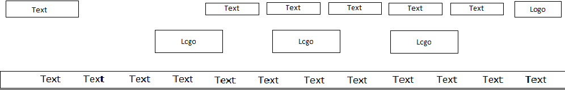

Figure (20): Header Wireframe.

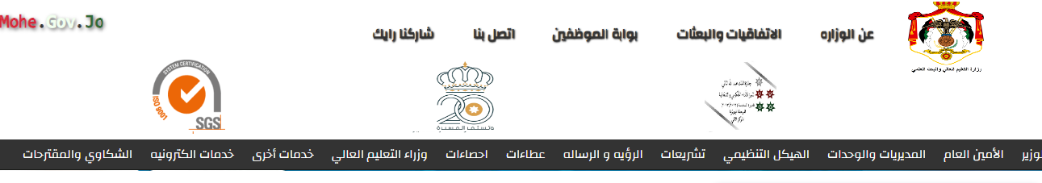

Figure (21): Header Mockup.

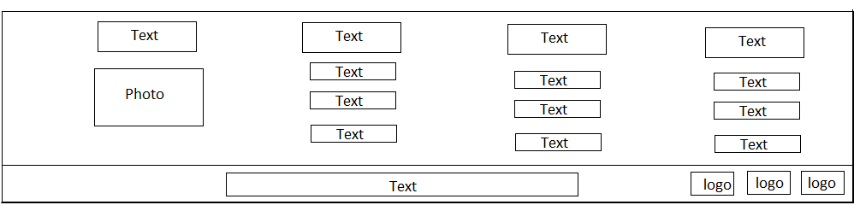

Figure (22): Footer Wireframe.

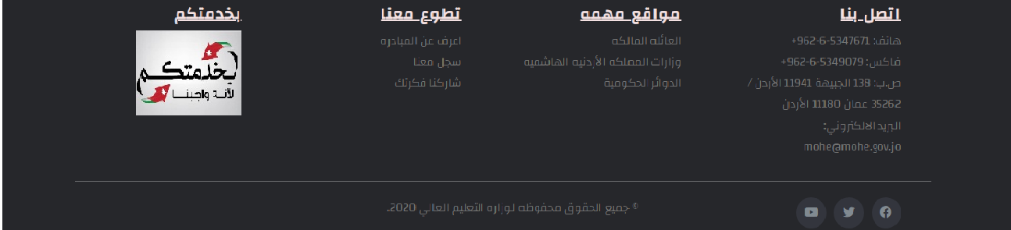

Figure (23): Footer Mockup.

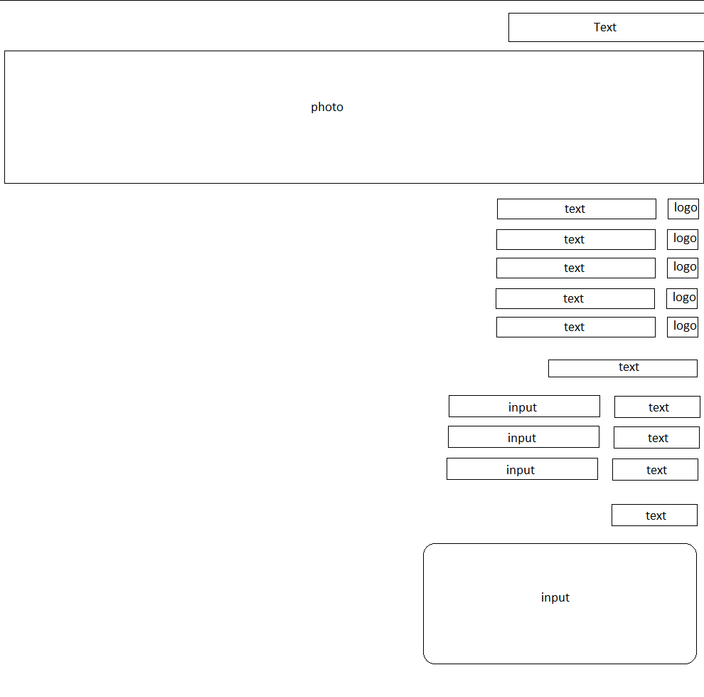

Figure (24): Contact-us page Wireframe.

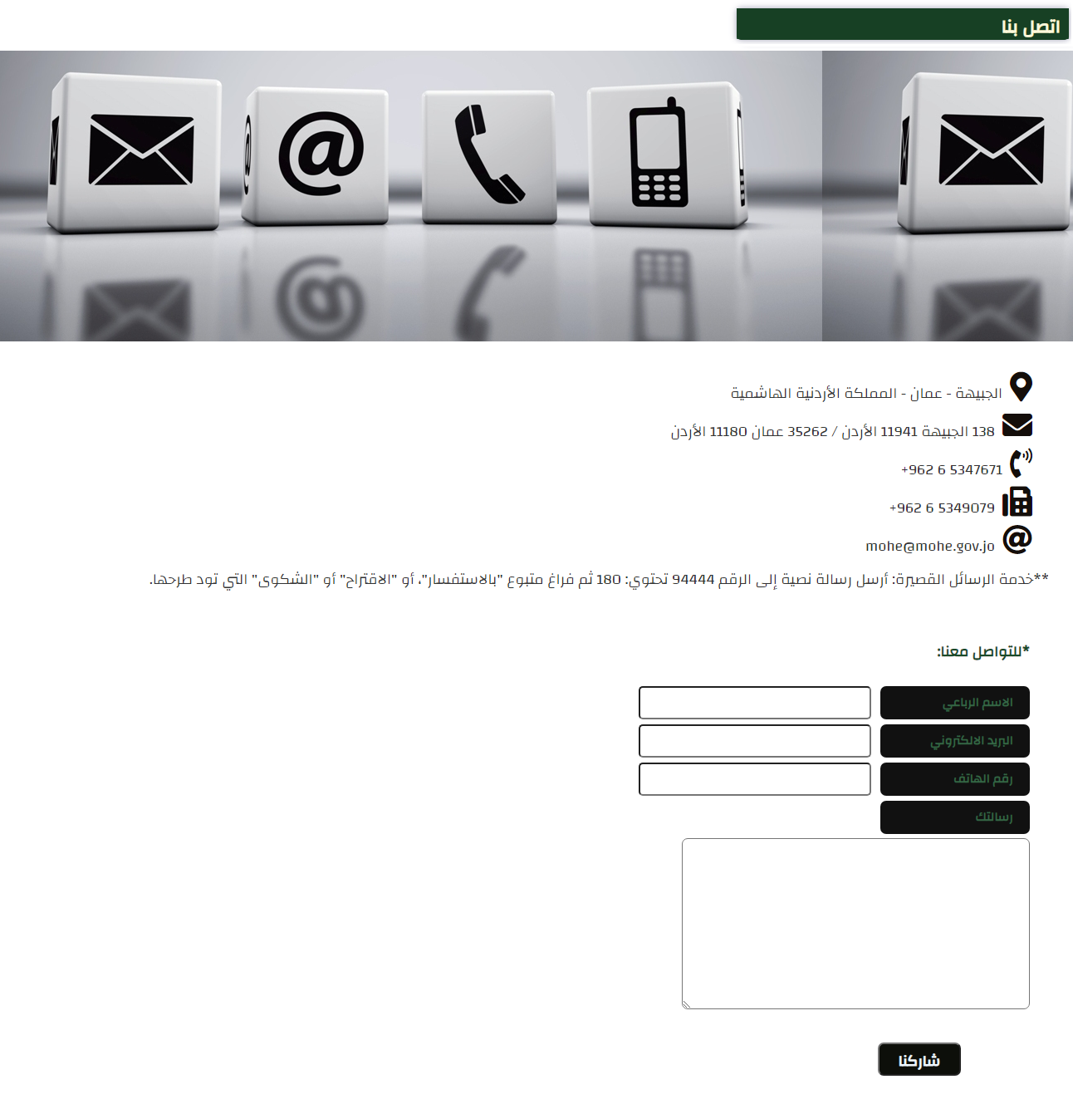

Figure (25): Contact-us age Mockup.

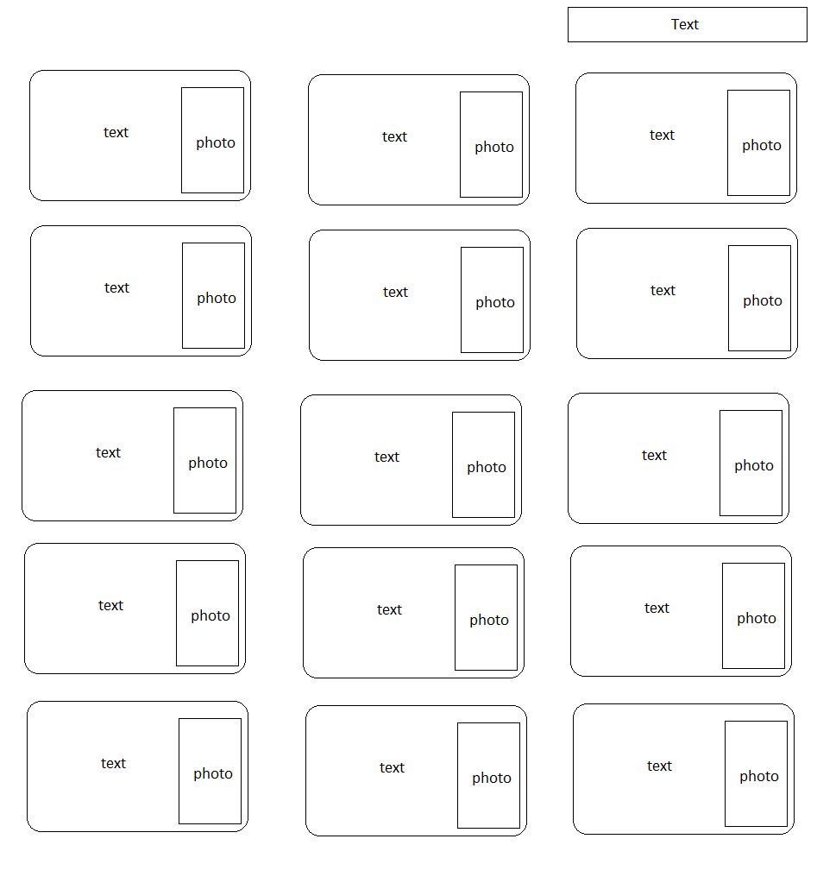

Figure (26): Minsters page Wireframe.

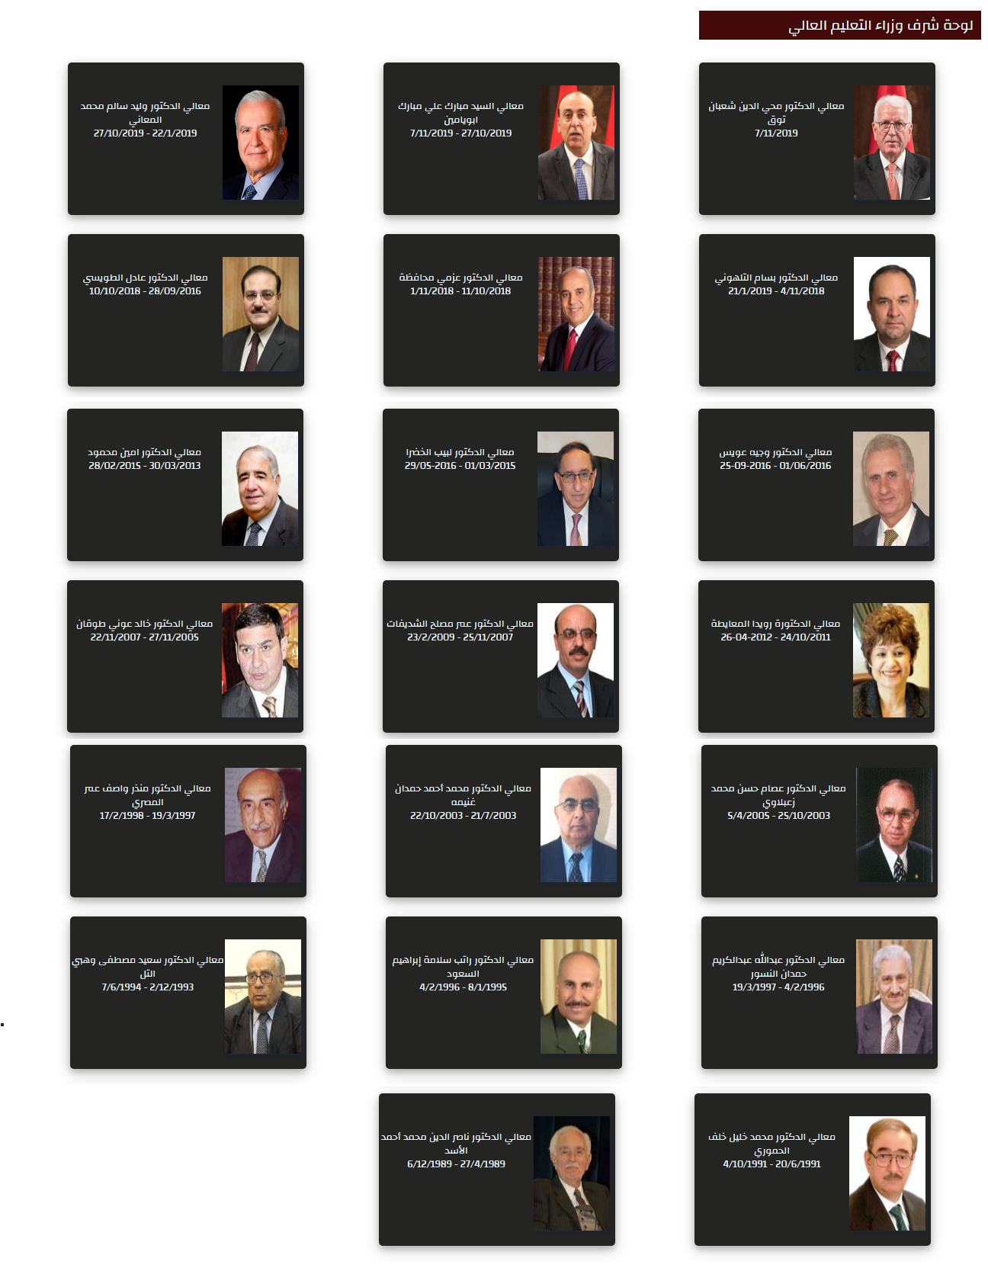

Figure (27): Minsters page Wireframe

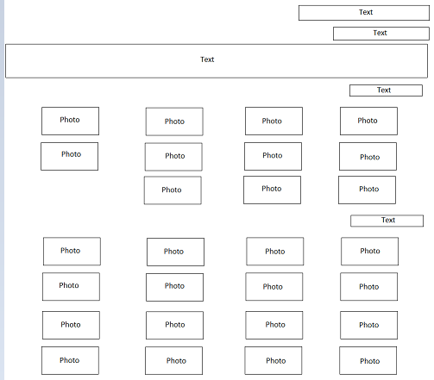

Figure (28): Conventions page Wireframe.

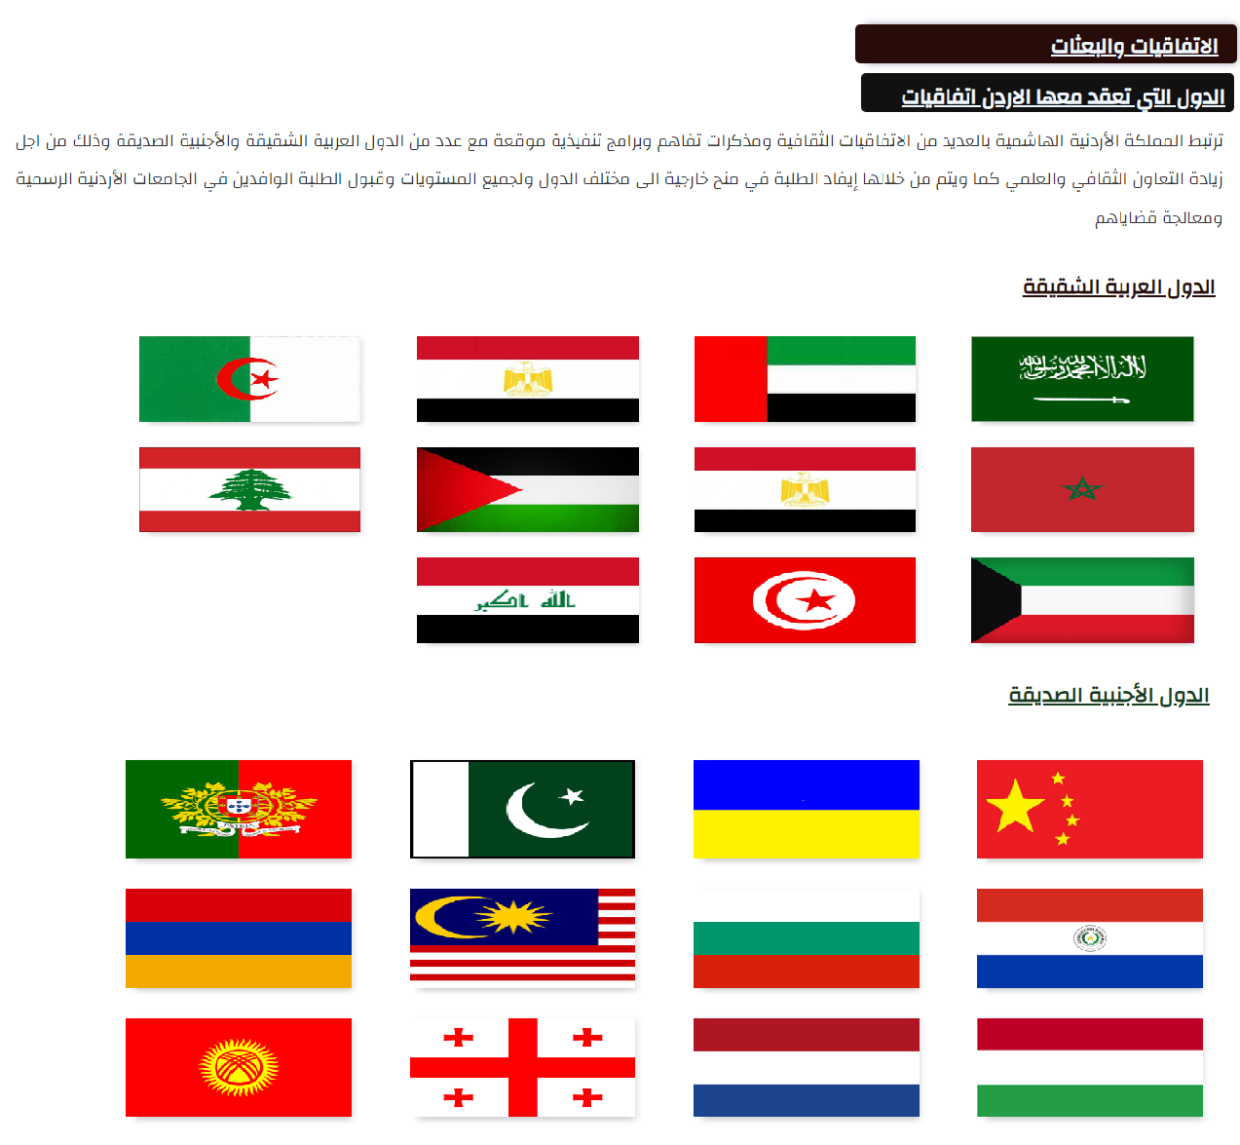

Figure (29): Conventions page Mockup.

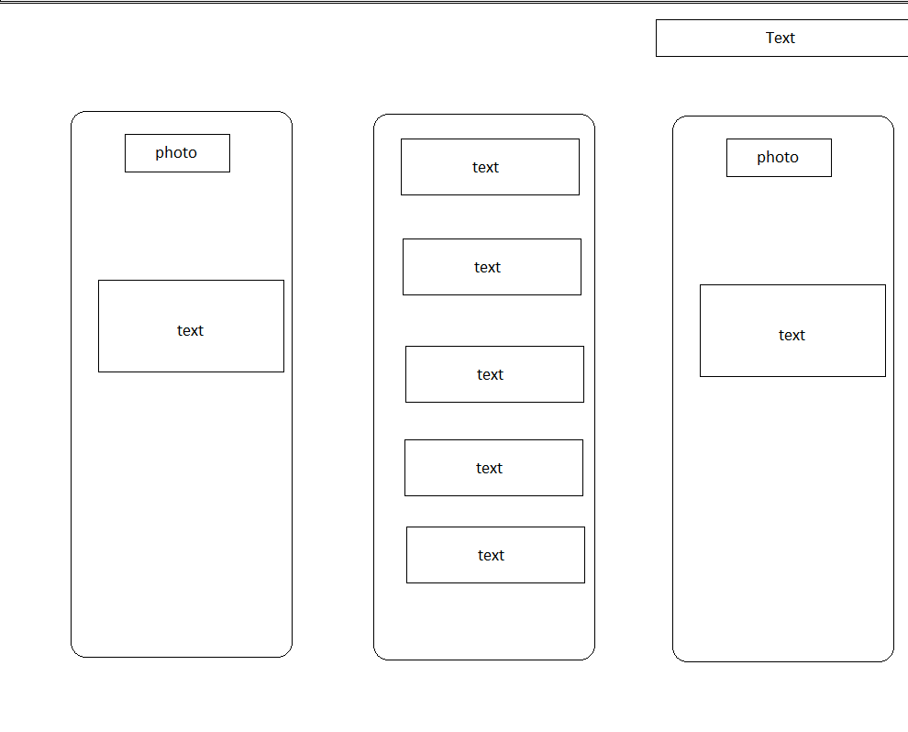

Figure (30): Collage page Wireframe.

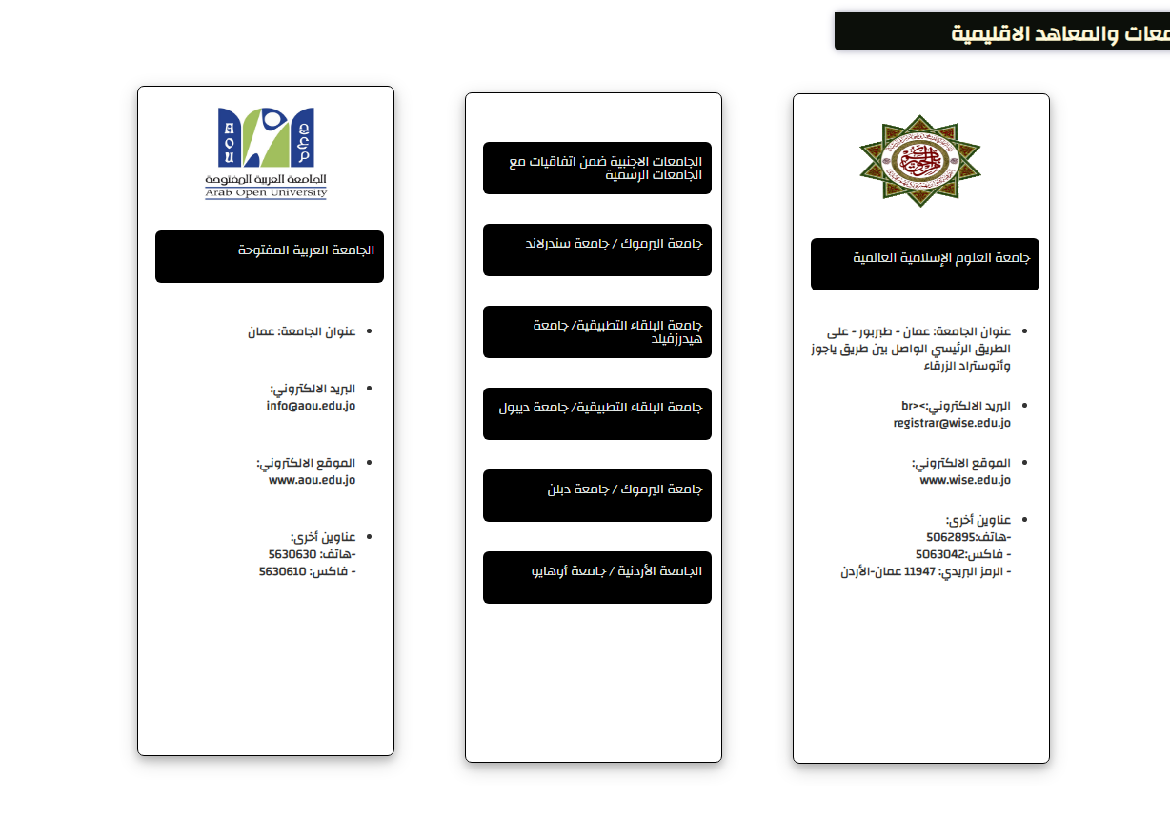

Figure (31): College page Mockup.

**9-Concluusion:**

The Internet plays an important role in our lives, because our life has become a small village thanks to it, through which we can easily reach people and services.

In view of that, web site developers play a big role in building this village, and this is what I did in my turn when I applied and used all of what you enjoyed during training, by developing the Ministry of Higher Education and Scientific Research website using modern and advanced programming languages, to provide a simple, elegant and at the same time easy to use site It provides the required services.

On my website, I have sought to provide the best electronic services with flexibility in order to save time, effort and money for users and beneficiaries, as well as for the Ministry and its employees.

I hope that we will like the site and that it meets your expectations. It was a wonderful and useful experience and it developed my scientific and personal skills. And it changed a lot of my concepts.

**10-Reffernces:**

1. http://www.mohe.gov.jo/ar/Pages/default.aspx
2. <https://en.wikipedia.org/wiki/Web_development>
3. <https://www.differential.com/posts/14-technologies-every-web-developer-should-be-able-to-explain>
4. <https://squareboat.com/blog/backend-developer-skills#:~:text=The%20key%20responsibilities%20of%20backend,that%20web%20applications%20function%20correctly>.
5. <https://socialhackersacademy.org/free-coding-bootcamp/?gclid=EAIaIQobChMI6qi4k-Ss7AIVCZiyCh1ZHQcVEAAYAiAAEgJo1_D_BwE>
6. <https://supportline.microfocus.com/documentation/books/sx22sp1/pidepl.htm#:~:text=Deploying%20your%20application%20means%20putting,the%20Internet%20or%20an%20intranet.&text=Server%20Web%20share%20paths%20and%20application%20URLs>
7. <https://www.php.net/manual/en/features>.
8. <https://www.betterteam.com/web-developer->
9. <https://en.wikipedia.org/wiki/Mockup#:~:text=In%20manufacturing%20and%20design%2C%20a,enables%20testing%20of%20a%20design>.
10. <https://www.experienceux.co.uk/faqs/what-is-wireframing/>
11. <https://www.lucidchart.com/pages/er-diagrams#:~:text=An%20Entity%20Relationship%20(ER)%20Diagram,each%20other%20within%20a%20system>
12. <https://www.w3schools.com/whatis>
13. https://www.gov.br/pt-br.